Section I: Scenario Demographics

Scenario Title: | Infant SVT
Date of Development: | (20/02/2018)
Target Learning Group: | Juniors (PGY 1 – 2) Seniors (PGY ≥ 3) All Groups

Section II: Scenario Developers

Scenario Developer(s): | Laura Simone, Olivia Ostrow, Sandra Cardenas, Lauren Brown, Sarah Doubleday, Sherri Grady
Affiliations/Institution(s): | Sick Kids Learning Institute
Contact E-mail (optional):

Section III: Curriculum Integration

Learning Goals & Objectives
Educational Goal: | To review the management of both stable/unstable SVT in an infant
CRM Objectives: | - Effectively lead a team through PALS algorithms and resuscitation of an infant  - Demonstrate high quality closed-loop communication during resuscitation  - Sensitively address patient’s mother and explain clinical course and expected disposition when patient stabilizes
Medical Objectives: | - Recognize and manage both stable and unstable SVT via PALS guidelines  - Rapidly estimate pediatric weight and utilize resources/ team members for resuscitation medication dosing  - Anticipate deterioration in a patient with compensated shock

Case Summary: Brief Summary of Case Progression and Major Events
The team has been called to the ED after a 12-month old is brought in with a rapid heart rate. The team will realize the patient is in a stable SVT rhythm, with no response to either vagal maneuvers or adenosine. The patient will then progress to having an unstable SVT. If the SVT is defibrillated (i.e. – shocked without synchronization), the patient will progress to VT arrest. If the SVT is cardioverted, the patient will clinically improve.

References
Marx, J. A., Hockberger, R. S., Walls, R. M., & Adams, J. (2013). Rosen's emergency medicine: Concepts and clinical practice. St. Louis: Mosby.
Helman, Anton. (2017). Emergency Medicine Cases. PALS Guidelines. Available from https://emergencymedicinecases.com/pals-guidelines/
PALS Guidelines 2015

Section IV: Scenario Script

A. Clinical Vignette: To Read Aloud at Beginning of Case
Mark is a 12- month old male who is brought into your ED today by his parents because he has been fussy, crying all night and not feeding well today. He had emesis x 1 (non-bilious, non-bloody). At triage, the RN had difficulty recording the heart rate but by auscultation it seemed “quite rapid”, and he “feels a bit warm”.
B. Scenario Cast & Realism
Patient: | Pediatrics Computerized Mannequin |  |  |  |  | Realism:  Select most important dimension(s) |  |  | Conceptual
 | Mannequin |  |  |  |  |  |  |  | Physical
 | Standardized Patient |  |  |  |  |  |  |  | Emotional/Experiential
 | Hybrid |  |  |  |  |  |  |  | Other:
 | Task Trainer |  |  |  |  |  |  |  | N/A
Confederates | Brief Description of Role
Nurse | To assist at bedside, describe infant’s status, and provide history.
Mother | Brought patient to ED, sits in room during resuscitation, asks questions re: plan post resuscitation
C. Required Monitors
EKG Leads/Wires |  |  | Temperature Probe |  |  |  | Central Venous Line
NIBP Cuff |  |  | Defibrillator Pads |  |  |  | Capnography
Pulse Oximeter |  |  | Arterial Line |  |  |  | Other:
D. Required Equipment
Gloves |  |  | Nasal Prongs |  |  |  | Scalpel
Stethoscope |  |  | Venturi Mask |  |  |  | Tube Thoracostomy Kit
Defibrillator |  |  | Non-Rebreather Mask |  |  |  | Cricothyroidotomy Kit
IV Bags/Lines |  |  | Pediatric Bag Valve Mask |  |  |  | Thoracotomy Kit
IV Push Medications |  |  | Pediatric Laryngoscope |  |  |  | Central Line Kit
PO Tabs |  |  | Video Assisted Laryngoscope |  |  |  | Arterial Line Kit
Blood Products |  |  | Pediatric ET Tubes |  |  |  | Other:
Intraosseous Set-up |  |  | LMA |  |  |  | Other:
E. Moulage
None

F. Approximate Timing
Set-Up: |  | 3 min |  | Scenario: | 15-20 min |  |  | Debriefing: |  | 20 min

Section V: Patient Data and Baseline State

A. Patient Profile and History
Patient Name: Mark |  |  |  |  |  | Age: 12 months |  |  |  |  |  |  |  | Weight: 10 kg
Gender: M F
Chief Complaint: Fussy, poor feeding x 1 day, URTI symptoms
History of Presenting Illness: Poor feeding x 1 day (breastfeed 2 hrs ago), URTI symptoms (dry cough, rhinorrhea) x 1 day, very fussy, consoles intermittently. No apneic episodes. No respiratory distress. Voiding OK. No fevers. No sick contacts. No travel.
Past Medical History: |  | Full term 38 weeks SVD |  |  |  |  | Medications: |  |  |  |  | None
 |  | GBS negative
 |  | Immunizations UTD
Allergies: NKDA
Social History: Lives at home with mom, normal development. No daycare
Family History: Non-contributory
Review of Systems: |  | CNS: |  |  | Alert, strong cry, active, moving 4 limbs, no nuchal rigidity, irritable but consolable
 |  | HEENT: |  |  | Nil
 |  | CVS: |  |  | Nil
 |  | RESP: |  |  | Cough, rhinorrhea x 1 day
 |  | GI: |  |  | Vomited once this morning (non-bloody, non-bilious). Stooling normal.
 |  | GU: |  |  | Normal urine output.
 |  | MSK: |  |  | Nil |  |  |  |  |  |  |  | INT: |  | Nil
B. Baseline Simulator State and Physical Exam
No Monitor Display |  |  |  | Monitor On, no data displayed |  |  |  |  |  |  | Monitor on Standard Display
HR: 220/min |  |  | BP: 82/p |  |  |  |  | RR: 50/min |  |  |  |  |  |  | O₂SAT: 95% RA
Rhythm: SVT |  |  | T: 37.2ºC |  |  |  |  | Glucose: 5.5 mmol/L |  |  |  |  |  |  | GCS: 15 (E4 V5 M6)
General Status: Alert, strong cry, active, consolable, pink colour
CNS: | Strong cry, opens eyes spontaneously, purposeful movements x 4 limbs, PEARL 3mm, no nuchal rigidity
HEENT: | Normal TM, mild pharyngeal erythema, no tonsillar exudates, ++rhinorrhea
CVS: | SVT, 220/min, cap refill 2 seconds (central and peripheral), normal femoral pulses, no cyanosis
RESP: | Equal air entry bilaterally no crackles or wheeze, mild retractions, mild nasal flaring
ABDO: | Soft, no organomegaly
GU: | Nil
MSK: | Nil |  |  |  |  |  |  |  | SKIN: | No bruises or signs of NAT

Section VI: Scenario Progression
Scenario States, Modifiers and Triggers
Patient State | Patient Status | Learner Actions, Modifiers & Triggers to Move to Next State
1. Baseline State  Rhythm: SVT  HR: 220/min  BP: 82/p  RR: 50/min  O₂SAT: 95%  T: 37.2ºC rectal | Irritable in mild respiratory distress  Mother asking what the treatment is | Learner Actions  - Apply 100% O2, monitors  - Obtain IV access, basic labs  - Check cap sugar: 5.5  - Obtain weight from RN  (10 kg) or use Broselow tape  - ECG  - Attempt vagal maneuvers (ice bag to face, rectal stim, gag/suction)  - Place defibrillator pads  - Adenosine 0.1 mg/kg (1mg) IV push with 5ml NS flush  - Adenosine 0.2 mg/kg (2 mg) IV push with 5 ml NS flush | Modifiers  Changes to patient condition based on learner action  - Adenosine 1 mg/kg SVT continues 220/min  - Adenosine 2mg/kg NSR x 5 secs, then returns to SVT @ 220/min  Triggers  - Adenosine given x2 2. Unstable SVT  - Synchronized cardioversion  2. Unstable SVT  - Unsynchronized defibrillation  3. VT Arrest
2. Unstable SVT  Rhythm: SVT  HR: 260/min  BP: 70/p  RR: 60  O2 SAT: 98% | Compensated shock (weak peripheral pulses, poor cap refill 4-5 seconds, mottled)  Mother asking for updates | Learner Actions  - IV NS 20 ml/kg bolus (200 ml)  - ± Midazolam 0.1-0.2mg/kg IN (1-2 mg) or 0.05 mg/kg IV (0.5 mg)  - ± Fentanyl 1.5 mcg/kg IN (15mg) or 0.5-1 mcg/kg IV (5-10mg)  - Synchronized cardioversion 0.5-1 J/kg (5-10J)  - Synchronized cardioversion 2J/kg (20J) | Modifiers  - Synchronized cardioversion 0.5-1 J/kg remains in SVT  Triggers  - Unsynchronized defibrillation performed 3. VT Arrest  - Synchronized cardioversion @ 2J/kg 4. Improved
3. VT Arrest  Rhythm: VT  HR: 190/min  BP: 0/0  RR: 0  O2 SAT: ? | Arrest state | Learner Actions  - Begin BVM with 100% O2  - CPR at 15:2 ratio until defibrillator ready  - Defibrillate at 2J/kg (20J)  - Continue CPR x 5 cycles (2 mins), pulse check @ 2 min  - Epi 0.01mg/kg IV (0.1 mg) | Modifiers  - If no PEEP valve used SpO2 to 88%  - If defib < 2J/kg continue in VTach  Triggers  - After 1 defib 4. Improved
4. Improved  Rhythm: Sinus tach  HR: 140/min  BP: 85/p  RR: 40 | Awake, alert, moving 4 limbs, crying, good cap refill, pink | Learner Actions  - Continuous 12 lead ECG monitoring, keep defib pads on  - Consult PICU/Cardiology  - Discuss plan with parent | END CASE PRN

Section VII: Supporting Documents, Laboratory Results, & Multimedia

Laboratory Results
None provided during case.

Images (ECGs, CXRs, etc.)
Initial ECG (SVT)
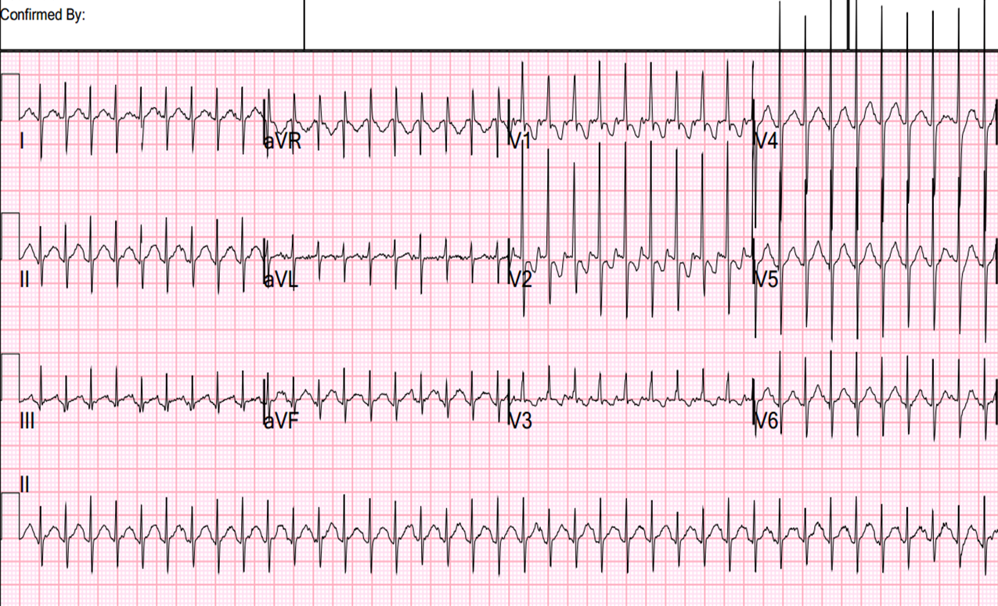

ECG source: http://hqmeded-ecg.blogspot.ca/2013/01/heart-rate-of-230-beats-per-minute.html
VTach ECG
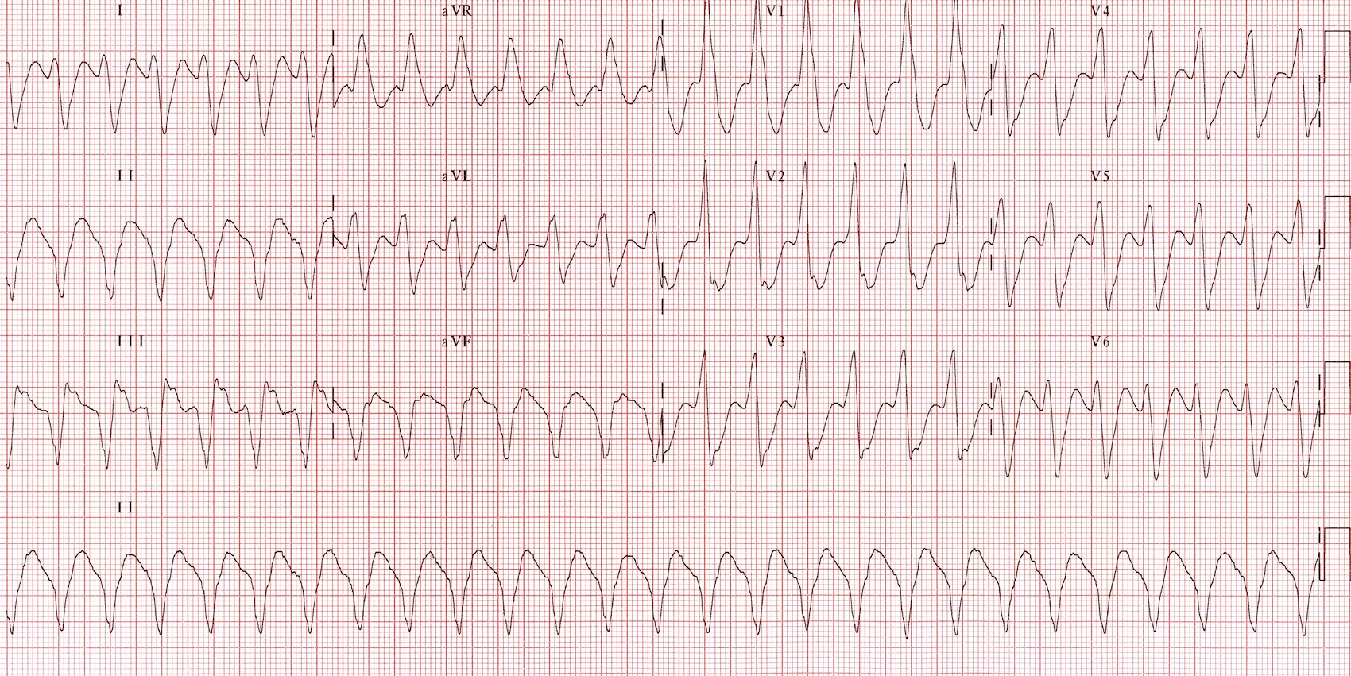
ECG source: https://lifeinthefastlane.com/ecg-library/ventricular-tachycardia/
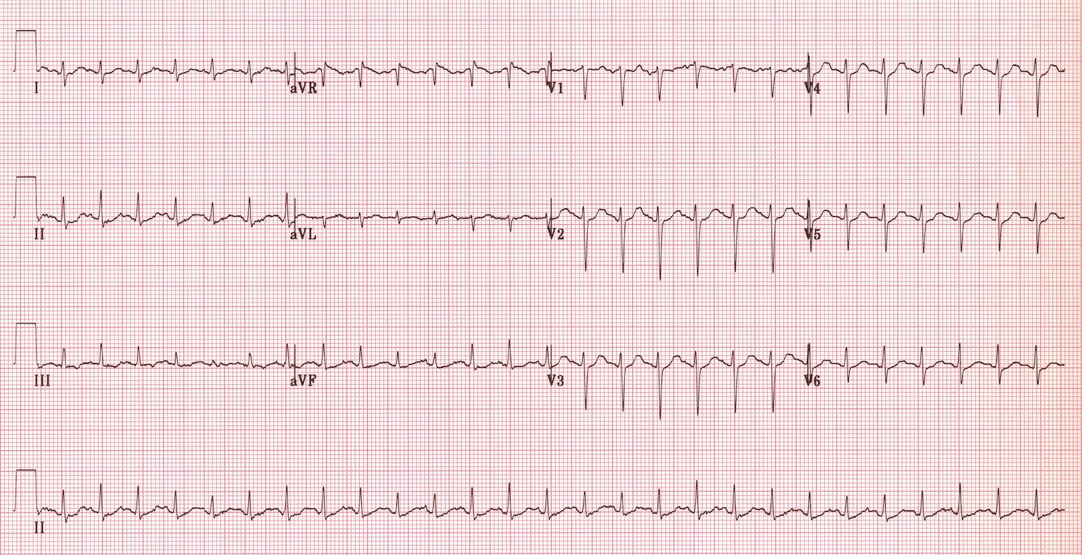
Post Cardioversion ECG

ECG source: http://lifeinthefastlane.com/ecg-library/sinus-tachycardia/

Section VIII: Debriefing Guide

General Debriefing Plan
Individual | Group |  | With Video | Without Video
Objectives
Educational Goal: |  | To review the management of both stable/unstable SVT in an infant
CRM Objectives: |  | - Effectively lead a team through PALS algorithms and resuscitation of an infant  - Demonstrate high quality closed-loop communication during resuscitation  - Sensitively address patient’s mother and explain clinical course and expected disposition when patient stabilizes
Medical Objectives: |  | - Recognize and manage both stable and unstable SVT via PALS guidelines  - Rapidly estimate pediatric weight and utilize resources/ team members for resuscitation medication dosing  - Anticipate deterioration in a patient with compensated shock
Sample Questions for Debriefing
- What are the components of the pediatric assessment triangle?
- Explain how to perform vagal maneuvers in an infant that cannot follow commands.
- How does adenosine work? How do you set up your IV tubing for an adenosine push? What are some expected signs/symptoms after adenosine is given?
- What are the features that distinguish SVT from sinus tachycardia?
Key Moments
- Recognition and management of stable/unstable SVT
- Recognition of compensated shock and need for fluid boluses
- Calculation of pediatric resuscitation medications and shock energy

